
THE NEWSLETTER OF THE NASHOBA VALLEY WEAVERS’ GUILD

WARPED

January 2010

Nashoba Valley Weavers’ Guild ~ PO Box 50 ~ Harvard MA ~ 01451

January 26
Susan Targove will tell us about her entry into the Handwoven Bra Project (sponsored by the Boston Area Weaver’s guild to raise money for, and awareness of, breast cancer). The Handwoven Bra Project recently won a FUZ-E award from Handwoven magazine. Susan’s presentation will be in two parts - “Ubi Textrix Via Est” (or what not to do) and “Designing with Blocks”. Handouts will be provided.
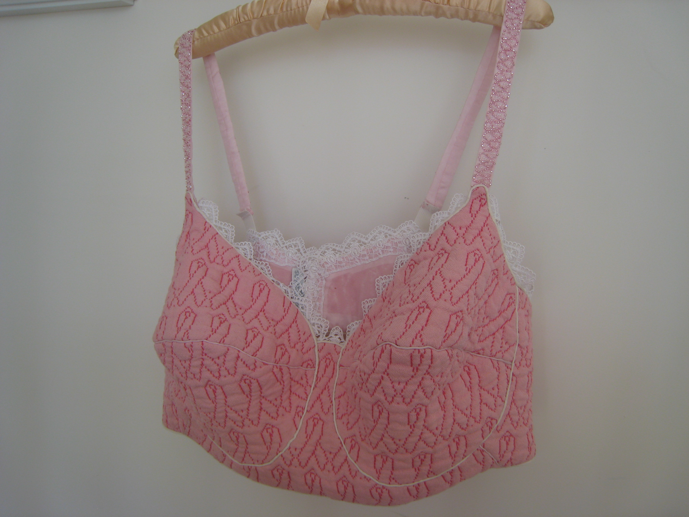

February 23
Lily Baddour – Art Baskets
Several years ago at Harvard University’s Peabody Museum, Lily Baddour saw a feathered basket as big as a dinner plate, covered in red woodpecker feathers and rimmed with topknots from California quail. It was made by a California Pomo Indian woman about one hundred years ago. Pomo feather baskets are technically and artistically awe-

inspiring. Lily was inspired to start experimenting in this art form, since it unites her love of fiber, handcraft and birds. She will bring in a small Pomo basket, some of her baskets and will discuss the medium.

March 23
Lies Stolk – Bobbin Lace
Bobbin lace is a textile technique typically made with linen, cotton or silk. The threads are wound on bobbins in pairs. The lace is
made on a pillow with the pattern attached. As the lace is made, it is pinned to the pillow to hold the threads in place. Lies Stolk has been teaching this technique for over 20 years. Lies will present and explain the differences in various types of lace. She will have a student pillow available for us to try the technique, and will also bring her personal pillow to demonstrate.

April 27
Adele Harvey – “What to do with Yesterday's News”
In this lecture/workshop we will get an overview of the history of paper yarn in Japan as well as other cultures. We will learn the process of preparing and spinning paper of various kinds (dressmaker’s pattern paper, Japanese Kozo paper, tissue paper, and newspaper). We will discuss suitable weaves and purposes for fabric made of spun paper.

May 25
Flip Loom Demonstration

June 22
Potluck Dinner

Meetings are held at the Fiber Loft in Harvard, MA. Refreshments, shopping and the access to the guild library start at 7pm and the meeting starts at 7:30.

INKLINGS
Here is a sampling of Inklings made at the December meeting presented by Dorothy Solbrig.

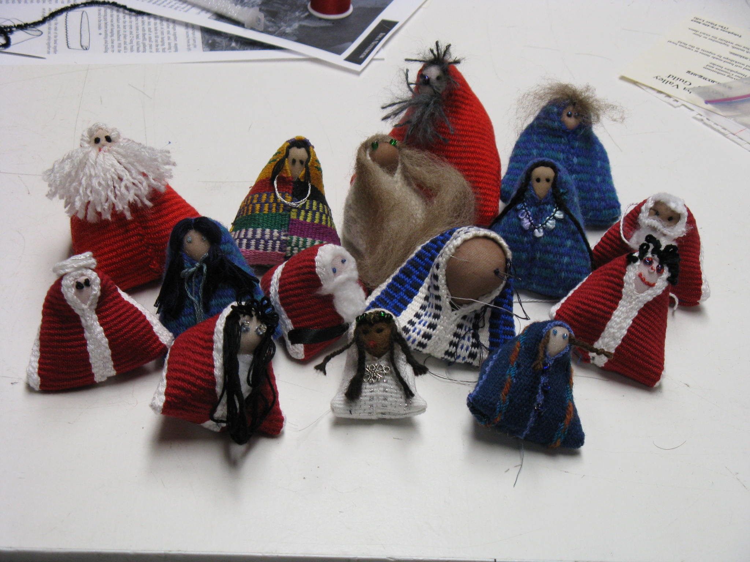

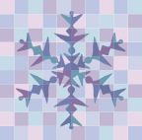
SNOW
CANCELLATION POLICY

If the weather outside is frightful how do you know if a meeting is cancelled? If the schools are closed in Harvard, MA then the meeting is cancelled. In addition the board will send out an email announcement by noon of the meeting day if the meeting will be cancelled. Finally, you can always call the Fiber Loft
(978) 456-8669 and inquire – if they are closed there will be no meeting!

Sheep to Shawl at the Wayside Inn
The Wayside Inn in Sudbury is planning to host a “Sheep to Shawl Day” on May 22. They are looking people to demonstrate traditional crafts such as spinning, weaving and dyeing. Information on the event will be on the Wayside Inn website at the end of January.
http://www.wayside.org/events
Please let us know if you're interested in demonstrating.

GUILD CHALLENGE

Thank you to everyone who submitted suggestions for this year’s Guild Challenge. There were some great ideas! In keeping with the theme of 3D this year our challenge is to create a fiber container. We are defining a container broadly as anything in which another object may be placed. Let your imagination run wild! Objects must be made of fiber and can use other materials as embellishments. Items will be displayed and prizes awarded at the potluck in June. Attendance at the potluck will not be required to participate in the challenge.

TWO EXHIBITS AT AMERICAN TEXTILE HISTORY MUSEUM IN LOWELL

Changing Landscapes: Contemporary Chinese Fiber Art
Thru March 14, 2010
The American Textile History Museum presents the first exhibition of contemporary Chinese fiber art ever to travel to the United States. Organized by the San Jose Museum of Quilts and Textiles, this exhibit celebrates virtuosity of technique and profound cultural and artistic expression.
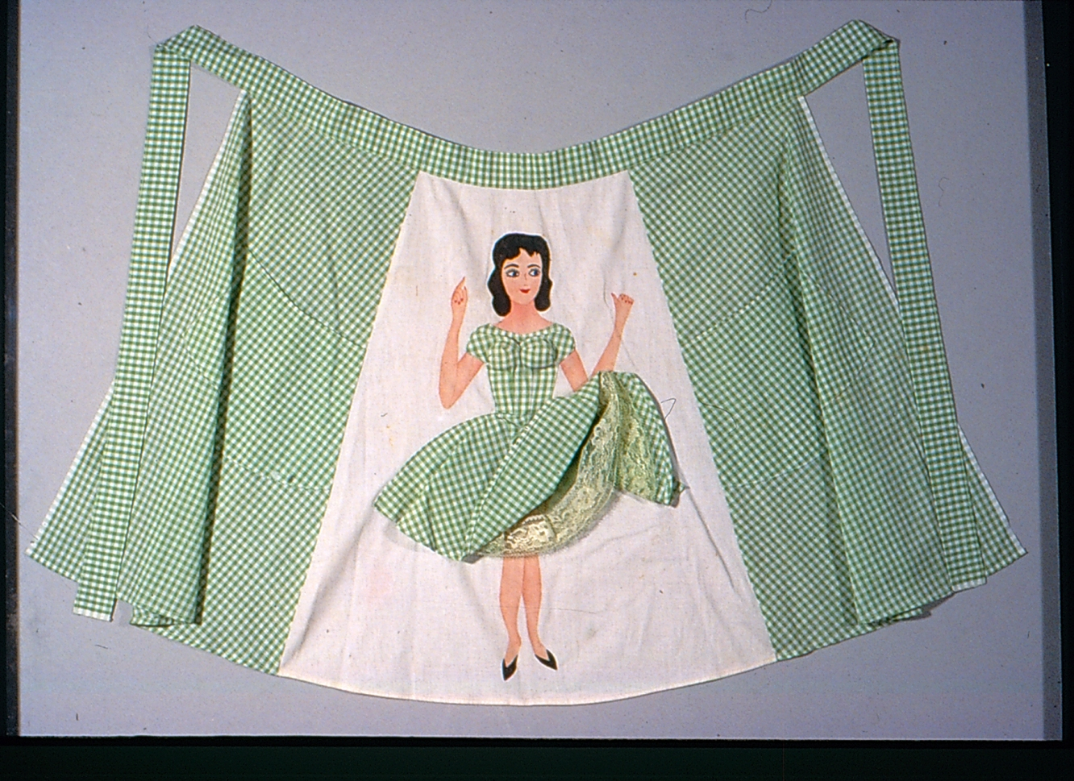

Aprons: Fifties
FUNctional Fashion
Thru March 28, 2010
Ah, those fabulous 50s! The mention of the era brings back memories of malt shops, diners, rock ’n roll, cocktail parties, and …aprons? Just think of June Cleaver and Harriet Nelson from the iconic TV series and try to imagine either of them in the kitchen without their aprons.

For more information about these exhibits visit:
http://www.athm.org/current_exhibitions.htm

Upcoming Events

May 1 and 2 – Open Studios at The Fringe Movement – Jenna Rivers, fashion designer, will host an open studio on May 1st and 2nd in Somerville, MA.. Josephine Rivers will demonstrate weaving and have weaving products on display. For more information: www.thefringemovement.com

Travel Opportunities for Weavers

The guild has received the following information on upcoming trips to Norway, Guatemala and Scotland.

International Workshop Invitation
Weaving and Design in Norway
Vesaas Farm Weaving Studio/ Mjonøy Handcraft and Cultural Center in Vinje, Telemark. Weave with Norwegian master weavers Eli Vesaas and Ingebjørg Vaagen on a working farm in the Telemark mountains. Each participant weaves fine Spelsau yarn into vadmel cloth during the first week. We full the cloth at a reconstructed water-powered fulling mill on the weekend, and we cut and sew custom designed garments inspired by Norwegian traditions during the second week. Sew your garment with expert guidance as you create a contemporary style with traditional sewing techniques and design details. Custom design and patterning result in a perfect fit. The
course is an immersion experience in Norway's rich rural textile culture. Course runs May 30 – June 12, 2010. Visit us online at www.mjonoy.no and clicking on kurs (course).
Email for details and registration information by February 15. Carol Colburn, Professor of Costume History and Design, University of
Northern Iowa, Cedar Falls, IA, USA
carol.colburn@uni.edu

Guatemalan Weaving
with Deborah Chandler
July 5-15, 2010
Harrisville Designs, Mayan Hands and Textile Indigo Artes are proud sponsors of a textile trip of a lifetime. Join us for a ten day tour that will include five days of instruction in a variety of traditional weaving techniques at Indigo Artes followed by four days of travel into the beautiful Guatemalan Highlands, visiting groups of Mayan weavers in their villages, as well as
textile markets, textile museums, and more. Neither extensive weaving experience nor Spanish is required, as the weaving techniques will be new to most and there will be translators
present at all times. Group size is limited to 12 participants, so look at your calendar now. To learn more, visit
www.harrisville.com/classes.htm

Scotland Tour
Threads, Ruins, & Tunes
April 8 - 21, 2010
Join the Singing Weaver on a tour of Scotland. Registration opens June 1. Read about the 2009 tour at www.singingweaver.blogspot.com

NVWG Yahoo Group
We would like to remind everyone that the Guild has a YahooGroup available. We would like to be able to use it to contact our entire membership, but not all members are subscribed. It's free, and you can decide if you want individual emails, a daily digest of emails for the day, or no emails (meaning you would need to log on to the YahooGroup site to view any postings). To subscribe, go to www.yahoogroups.com. In the "Find a Yahoo! Group" box, type "nvwg" and click the search button. Our group, entitled "nvwg", should come up in the search results with a "Join This Group" link. Click the link and follow the instructions. If you have any trouble subscribing, please let us know and we can "force" your subscription from our end. I will post our meeting reminder to the YahooGroup list, so you will have some indication if you're already subscribed.

The Nashoba Valley Weavers’ guild has a number of books and magazines available for members to borrow. For a list of available items and information on how to borrow them go to: http://www.nvwg.org/library.html

Website links: If you have a fiber-related website and would like to be linked to the NVWG website, please email your website address to Jboutotte@charter.net and it will get added to our website.

